Key word & Thesis Highlight

Every doctoral student needs to submit ‘a list of Keywords’ & one page Highlight in word document while submitting thesis to HBNI central office for awarding Ph.D. degree.

Highlight needs to have a 'representative colour graphics of the content of the thesis' / 'New Laboratory setup if it is developed as a part of the thesis' with editable caption (Font: Calibri Italics, Size 10). Highlight Text is (Font: Calibri, Size 11) limited to one page with embedded graphics.

Student has to send his/her thesis Keyword (file name: key-enrollment number, eg. key-phys01201404001) and Highlight (file name: high-enrollment number, eg. high-phys01201404001) to HBNI central office by email (Email: highlight@hbni.ac.in) as attachments of two different files with email subject ‘keyword and highlight-enrolment number’

A sample page of highlight (with incomplete header) is attached in the next page for convenience.

Student has to submit highlight with completed header.

Thesis Highlight
Name of the Student:
Name of the CI/OCC: Enrolment No.:
Thesis Title:
Discipline: eg. Life Sciences Sub-Area of Discipline: Cancer Epigenetics
Date of viva voce:

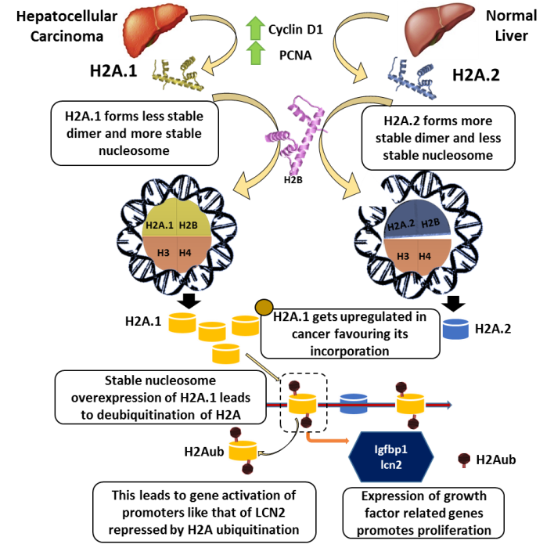
Histones are a class of highly conserved basic proteins and packaging the genome was the primary function previously attributed to them. The core histones comprise of H2A, H2B, H3 and H4 which assemble as hetero-oligomers to form the octameric protein core of the fundamental repeating unit of chromatin, the nucleosome. Histone genes are present in clusters and in multiple copies. For instance, in humans, H2A is coded by 16 genes. All of these genes do not code for the identical protein and give rise to sequence divergent forms of histones termed isoforms. H2A isoforms are known to exhibit altered expression under different physiological conditions. Their distinct functional effects remain a matter of investigation and the mechanistic basis of the non-redundancy is elusive.
Here, it is shown that isoform H2A.1 exhibits drastically altered expression pattern in normal tissues and cancer cells. It is of functional importance as H2A.1 promotes cell proliferation in a context dependent manner. For carrying out comparative analysis of the stability of H2A.1 and H2A.2 containing nucleosome and sub-nucleosomal complexes in vitro, the histone proteins were recombinantly purified. Further, sub-nucleosomal complexes were reconstituted and purified. Biophysical characterization showed that M51L alteration at the dimer interface decreases the temperature of melting of H2A.1-H2B by ~3⁰C as compared to H2A.2-H2B dimer. Further, M51L and K99R substitutions made H2A.1 containing nucleosomes more stable by increasing the number of hydrogen bonds and hydrophobic interactions. Interestingly, the same two substitutions had the most prominent effect on cell proliferation suggesting that the nucleosome stability is intimately linked with the physiological effects observed. In summary, the incorporation of the histone isoform H2A.1 resulted in increased nucleosome stability, which is expected to contribute to the contextual alteration in global transcription pattern and other chromatin mediated processes.
Figure 1. Histone H2A.1 Promotes Attainment of Distinct Physiological States by Altering Chromatin Dynamics in hepatocellular carcinoma

Note: Content (Font: Calibri, Size 11) and embedded Figure with editable Figure caption (Font: Calibri, Size 10, Italics) should be within one page.

